TITLE PAGE

NETSAGE AI

AI-Assisted Cisco / Packet Tracer Troubleshooting with Mandatory Human Review

Cisco VIP 2026 – Internship Project

Submitted by:
Name: Boby Kumar

Section: 2CSE37

Course: B.Tech CSE

Roll No.: 25SCS1003002634
College: IILM University, Greater Noida
Technology: Artificial Intelligence

Submitted to:
Cisco Networking Academy

Academic Year: 2025-2029

2. ABSTRACT
NetSage AI is an AI-assisted troubleshooting application designed to support Cisco and Packet Tracer network troubleshooting. The system analyzes network symptoms and available topology or command-output evidence to generate a possible root cause, confidence level, OSI layer, supporting evidence, next diagnostic command, and suggested fix steps.
A key feature of the system is its mandatory human-review mechanism. The AI diagnosis is not treated as an automatic configuration instruction. Instead, a human reviewer can accept, edit, or reject the diagnosis and provide a reviewer note and final diagnosis.
The project contains 30 troubleshooting cases, including 24 High/Critical severity cases. The current project review log contains 9 review records, with a displayed AI/Human agreement metric of 56%. These results demonstrate the importance of combining automated AI assistance with human validation for network troubleshooting.

3. INTRODUCTION

Network troubleshooting often requires examining multiple sources of evidence such as IP addressing, VLAN configuration, routing tables, gateway information, DNS configuration, and access-control settings.

NetSage AI provides an interface where a troubleshooting case can be selected and its symptom and network evidence can be examined. The system provides two complementary mechanisms:

Rule Checker for deterministic evidence-based checks.

AI Diagnosis for generating a structured troubleshooting diagnosis.

The application also maintains a review log so that human decisions can be recorded and used to evaluate the AI's performance.

The project therefore focuses not only on AI-assisted diagnosis but also on responsible use of AI in technical troubleshooting.

4. PROBLEM STATEMENT

The project addresses the problem of assisting users in diagnosing Cisco/networking issues from symptoms and available network evidence while ensuring that AI-generated recommendations are reviewed by a human before any configuration change is applied.

The system should help identify possible network faults, explain the evidence supporting the diagnosis, recommend the next command for investigation, and provide suggested remediation steps.

At the same time, incorrect AI diagnoses must be identifiable and correctable through human review.

5. PROJECT OBJECTIVES

The main objectives of NetSage AI are:

To provide AI-assisted network troubleshooting.

To analyze network symptoms and available evidence.

To identify possible root causes.

To provide confidence and OSI-layer information.

To recommend appropriate diagnostic commands.

To provide structured troubleshooting/fix steps.

To provide deterministic checks through a Rule Checker.

To enforce human review before configuration changes.

To record reviewer decisions and final diagnoses.

To provide dashboard-based project metrics.

To document cases where human review is required to correct or validate AI output.

6. PROPOSED SOLUTION – NETSAGE AI

NetSage AI is designed as a web-based troubleshooting assistant for Cisco/networking problems. It combines deterministic rule-based checking with AI-assisted diagnosis and mandatory human validation.

The system accepts a troubleshooting case containing the symptom and topology/show evidence. Based on this information, it can perform rule-based checks or generate an AI diagnosis.

The AI diagnosis provides:

Root Cause

Confidence

OSI Layer

Supporting Evidence

Next Diagnostic Command

Suggested Fix Steps

The system does not automatically apply configuration changes. Instead, the generated diagnosis is presented to a human reviewer who can Accept, Edit, or Reject it.

7. SYSTEM WORKFLOW

The overall workflow of NetSage AI is:

Troubleshooting Case → Evidence Analysis → Rule Checker / AI Diagnosis → Human Review → Final Diagnosis → Review Log → Dashboard

Step 1 – Select Troubleshooting Case

The user selects one of the available cases from the application.

Each case contains information such as:

Case ID

Network symptom

Network evidence

Expected fault

OSI layer

Networking concept

Severity

Step 2 – Analyze Evidence

The system combines the reported symptom and available network evidence for analysis.

For example:

VLAN 30 active; PC gateway 192.168.30.1; server 192.168.40.10; show ip route has no 192.168.40.0/24

This evidence can indicate a possible routing problem.

Step 3 – Rule Checker

The Rule Checker performs deterministic checks against the available evidence.

If a known condition is detected, the application displays the corresponding finding. If no rule matches, the application informs the user that additional evidence should be collected.

Step 4 – AI Diagnosis

The NetSage AI Diagnosis analyzes the symptom and evidence and produces a structured diagnosis.

The output includes the suspected root cause, confidence, OSI layer, evidence, next command, and recommended troubleshooting steps.

Step 5 – Mandatory Human Review

AI output is not automatically treated as the final answer.

The reviewer must select one of three decisions:

Accepted – AI diagnosis is confirmed.

Edited – AI diagnosis requires correction or modification.

Rejected – AI diagnosis is not supported by the evidence.

The reviewer can also enter a note and specify the final diagnosis.

Step 6 – Save Review

After human validation, the review is stored in review_log.csv.

This creates a record containing:

Case ID

Review status

Reviewer note

Final diagnosis

Step 7 – Dashboard

The dashboard summarizes the current project data, including:

Total cases

High/Critical cases

Review records

AI/Human agreement

Cases by issue type

Cases by severity

8. SYSTEM ARCHITECTURE

┌──────────────────────┐

│ Troubleshooting │

│ Case │

└──────────┬───────────┘

│

▼

┌──────────────────────┐

│ Symptom + Network │

│ Evidence │

└──────────┬───────────┘

│

┌──────────┴───────────┐

│ │

▼ ▼

┌─────────────────┐ ┌─────────────────┐

│ Rule Checker │ │ AI Diagnosis │

└────────┬────────┘ └────────┬────────┘

│ │

└──────────┬───────────┘

▼

┌──────────────────────┐

│ Human Reviewer │

│ Accept/Edit/Reject │

└──────────┬───────────┘

│

▼

┌──────────────────────┐

│ Final Diagnosis │

│ + Review Log │

└──────────┬───────────┘

│

▼

┌──────────────────────┐

│ Dashboard │

└──────────────────────┘

9. IMPLEMENTATION

NetSage AI was implemented as a Streamlit-based web application. The application uses separate Python modules for AI diagnosis and rule-based network checking, while CSV files are used for storing the troubleshooting cases and human-review records.

9.1 Application Interface

The main application provides three sections:

Troubleshooter – used to select a case, view network evidence, run the Rule Checker, and generate an AI diagnosis.

Dashboard – displays project-level statistics and visualizations.

Responsible AI – displays the human-review records maintained by the system.

9.2 Case Data

The troubleshooting cases are loaded from:

data/cases.csv

Each case contains information such as the symptom, network evidence, expected fault, OSI layer, networking concept, and severity.

9.3 Rule Checker

The Rule Checker is implemented through the rule_checker.py module. It performs deterministic checks against the troubleshooting text and displays matching findings.

This provides an evidence-based mechanism alongside the AI-assisted diagnosis.

9.4 AI Diagnosis Module

AI diagnosis functionality is implemented through the ai_diagnosis.py module.

The application passes the selected case's symptom and evidence to the diagnosis function. The resulting structured output is displayed in the Troubleshooter interface.

9.5 Review Log

Human-review information is stored in:

review_log.csv

When a reviewer saves a decision, the application records the case ID, review status, reviewer note, and final diagnosis.

This allows the project to maintain an auditable record of human validation.

9.6 Visualization

The Dashboard uses Matplotlib to visualize the distribution of cases by networking concept and severity.

The current project contains 30 cases, of which 24 are classified as High/Critical.

10. AI DIAGNOSIS & RULE CHECKER

NetSage AI uses two complementary approaches for network troubleshooting: a deterministic Rule Checker and an AI Diagnosis module.

10.1 Rule Checker

The Rule Checker analyzes the symptom and available network evidence and searches for known, deterministic troubleshooting conditions.

When a rule matches, the corresponding finding is displayed to the user. When no rule matches, the system displays a message indicating that additional evidence should be collected.

This approach helps provide a transparent and evidence-based troubleshooting mechanism.

10.2 AI Diagnosis

The AI Diagnosis module receives the selected case's symptom and topology/show evidence.

The generated diagnosis contains:

Root Cause

Confidence

OSI Layer

Evidence

Next Command

Fix Steps

For example, when the evidence indicates that VLAN 30 is active but the routing table does not contain the 192.168.40.0/24 network, the system can identify Missing inter-VLAN route as the root cause and recommend checking show ip route.

10.3 Importance of Evidence

The system presents the evidence used for the diagnosis instead of displaying only a final answer. This allows the reviewer to evaluate whether the suggested diagnosis is supported by the available networking information.

10.4 Human Validation

The AI output is treated as an assistance mechanism rather than an automatic configuration authority. Before a configuration change is applied, the diagnosis must be reviewed by a human.

11. HUMAN-IN-THE-LOOP REVIEW

A major feature of NetSage AI is its mandatory human-review mechanism. The system does not treat an AI-generated diagnosis as automatically correct or authorize an automatic configuration change.

After the AI generates a diagnosis, the reviewer is shown a warning:

HUMAN REVIEW REQUIRED — do not apply a configuration change until reviewed.

The reviewer can select one of three decisions:

11.1 Accepted

The reviewer confirms that the AI diagnosis is supported by the available network evidence.

11.2 Edited

The reviewer determines that the AI has identified the general problem but that some part of the diagnosis needs to be corrected or refined.

11.3 Rejected

The reviewer determines that the AI diagnosis is not supported by the evidence and records the appropriate final diagnosis.

11.4 Reviewer Note

The reviewer can enter an explanation describing why the diagnosis was accepted, edited, or rejected.

11.5 Final Diagnosis

The reviewer can specify the final diagnosis after evaluating the AI output and the available evidence.

11.6 Review Logging

After selecting the decision and entering the relevant information, the reviewer can save the review. The application stores the review in review_log.csv.

The stored information includes:

Case ID

Review Status

Reviewer Note

Final Diagnosis

This creates a traceable record of human intervention and allows the project to evaluate AI/human agreement.

11.7 Importance of Human Review

Human review is particularly important in network troubleshooting because an incorrect configuration recommendation could affect network connectivity or security. NetSage AI therefore positions AI as a decision-support tool, while the human reviewer remains responsible for validating the diagnosis before action is taken.

12. DASHBOARD & RESULTS

The NetSage AI dashboard provides a quick overview of the project's troubleshooting dataset and human-review activity. It presents key metrics and visualizations so that the overall project status can be monitored easily.

12.1 Project Metrics

The current dashboard displays the following results:
Metric | Current Result
Total Cases | 30
High/Critical Cases | 24
Review Records | 9
AI/Human Agreement | 56%

12.2 Cases by Issue Type

The dashboard provides a bar chart showing the number of cases associated with different networking concepts. This helps identify the types of networking problems represented in the troubleshooting dataset.

12.3 Cases by Severity

A second visualization displays the distribution of cases according to their severity. The dataset contains 30 cases, with 24 classified as High/Critical.

12.4 Review Activity

The dashboard also tracks the number of human-review records. At the current stage of the project, 9 review records have been recorded.

The displayed 56% AI/Human Agreement represents the current project review-log metric. As additional cases are reviewed, this value can change.

12.5 Results Interpretation

The dashboard demonstrates that NetSage AI is not limited to producing individual troubleshooting diagnoses. It also maintains project-level information about case severity and human validation.

The review metrics provide a way to monitor how often the AI diagnosis agrees with the human review process.

Figure 1: NetSage AI Project Dashboard
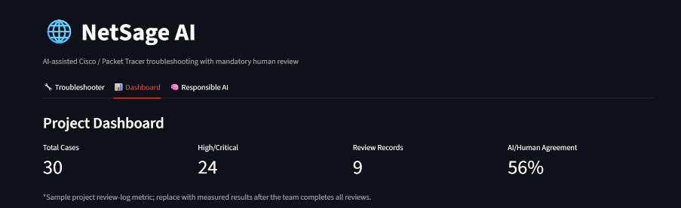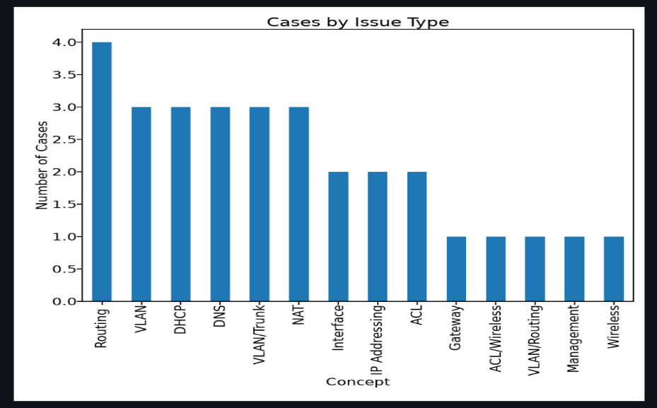
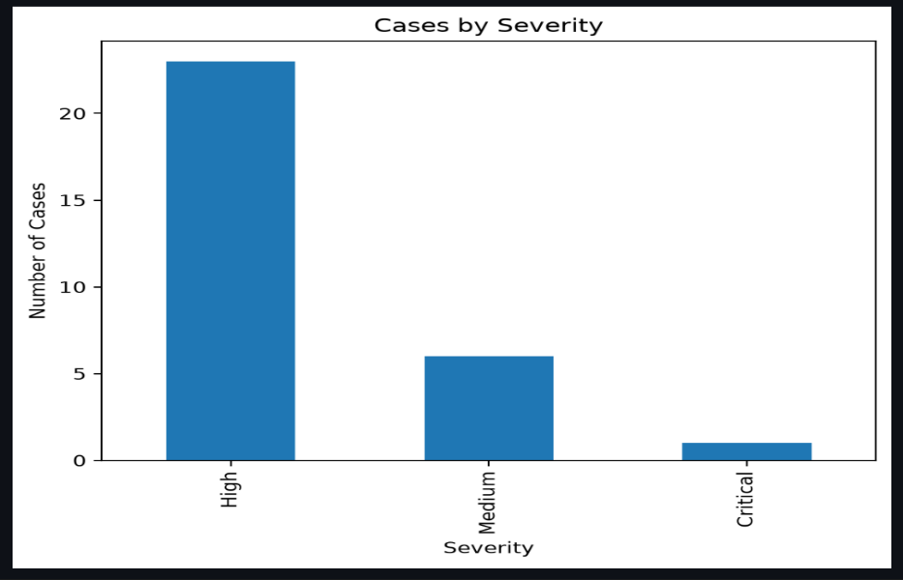
13. RESPONSIBLE AI
NetSage AI is designed with a human-in-the-loop approach so that AI-generated troubleshooting recommendations are reviewed before any configuration change is applied.
13.1 Human Oversight
The application explicitly informs the reviewer that human validation is required. The AI diagnosis is therefore used as a decision-support output rather than an automatic instruction.
13.2 Accept, Edit, or Reject
The reviewer can choose:
- Accepted – the diagnosis is confirmed.
- Edited – the diagnosis is modified based on human assessment.
- Rejected – the diagnosis is not accepted.
This allows incorrect or incomplete AI outputs to be identified and corrected.
13.3 Evidence-Based Decision Making
The application displays the evidence supporting the AI diagnosis, including the relevant network symptoms and show-command information. This allows the reviewer to independently evaluate the recommendation.
13.4 Review Logging
Every saved review records the case ID, review status, reviewer note, and final diagnosis in review_log.csv.
This provides a record of how the AI output was evaluated by a human.
13.5 AI Limitations
AI-generated diagnoses may be incorrect, incomplete, or based on insufficient evidence. For this reason, NetSage AI does not rely exclusively on AI output. The Rule Checker and human-review process provide additional validation mechanisms.
13.6 Current Review Results
At the current stage, the project contains 9 review records and displays an AI/Human Agreement of 56% on the dashboard. This metric represents the current review-log results and may change as additional cases are evaluated.
14. SAMPLE CASE ANALYSIS
To demonstrate the working of NetSage AI, one troubleshooting case was evaluated using the application.
14.1 Case Description
Symptom:
PC has IP but cannot reach server.
Network Evidence:
VLAN 30 is active, the PC gateway is 192.168.30.1, and the server is 192.168.40.10. The routing table does not contain the 192.168.40.0/24 network.
14.2 AI Diagnosis
Based on the available evidence, NetSage AI identified the following:
Parameter | Diagnosis
Root Cause | Missing inter-VLAN route
Confidence | High
OSI Layer | Layer 3
Concept | Routing
Severity | High
Next Command | show ip route
14.3 Recommended Fix
The system recommends:
- Verify the destination network 192.168.40.0/24.
- Add or correct the required inter-VLAN route.
- Verify connectivity between VLAN 30 and VLAN 40.
The recommendation is presented to the human reviewer before any configuration change is made.
14.4 Human Review
The reviewer evaluates the diagnosis using the provided network evidence and selects an appropriate decision such as Accepted, Edited, or Rejected. A reviewer note and final diagnosis can also be recorded.

14.5 Outcome
This example demonstrates the complete NetSage AI workflow:
Network Symptom → Evidence → Rule/AI Analysis → Diagnosis → Recommended Action → Human Review → Review Log

Figure 2: NetSage AI Sample Troubleshooting Diagnosis
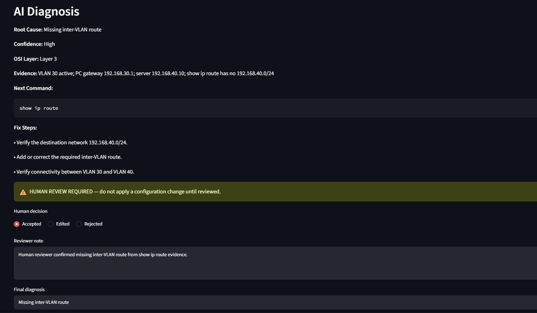

15. TESTING & VALIDATION
NetSage AI was tested using the troubleshooting cases available in the project dataset. The testing focused on whether the application could display the case information, generate a diagnosis, provide troubleshooting guidance, and record human review.
15.1 Functional Testing
The following major functions were tested:
Test | Expected Result | Status
Select troubleshooting case | Case details are displayed | Passed
Run Rule Checker | Relevant deterministic findings are displayed | Passed
Run NetSage AI Diagnosis | AI diagnosis is generated | Passed
Display evidence | Supporting network evidence is shown | Passed
Display next command | Troubleshooting command is provided | Passed
Display fix steps | Recommended steps are shown | Passed
Human review | Reviewer can Accept/Edit/Reject | Passed
Save Review | Review is stored in review_log.csv | Passed
Dashboard | Project metrics and charts are displayed | Passed
Responsible AI log | Review records are displayed | Passed
15.2 Validation of Sample Case
For the sample case, the application successfully identified the missing inter-VLAN route as the root cause based on the supplied evidence. It also provided show ip route as the next command and displayed recommended corrective steps.
15.3 Review Validation
The review mechanism was validated by saving human decisions through the application. The current project contains 9 review records, which are also reflected on the Dashboard.
15.4 Overall Testing Result
The testing confirms that the major components of the NetSage AI prototype work together as an integrated troubleshooting workflow:
Case Selection → Rule Checking → AI Diagnosis → Human Review → Review Logging → Dashboard
This validates the core functionality of the proposed system.
16. LIMITATIONS & FUTURE SCOPE
16.1 Limitations
Although NetSage AI provides an integrated troubleshooting workflow, the current prototype has some limitations:
- Evidence Dependency: The quality of the diagnosis depends on the network symptom and evidence provided to the system.
- AI Accuracy: AI-generated diagnoses may sometimes be incomplete or incorrect and therefore require human validation.
- Prototype Scope: The current system is focused on Cisco/Packet Tracer troubleshooting scenarios represented in the project dataset.
- Manual Configuration: The system recommends troubleshooting or corrective steps but does not automatically apply configuration changes.
- Review Dataset: The current review results are based on the reviews recorded so far and may change as more cases are evaluated.
16.2 Future Scope
The project can be extended in several ways:
- Add more networking troubleshooting cases and scenarios.
- Support additional Cisco show-command evidence.
- Improve the diagnosis engine using a larger and more diverse dataset.
- Add more detailed confidence and evidence analysis.
- Provide richer dashboard analytics for review performance.
- Add additional validation checks before presenting a recommended fix.
- Expand the human-review and audit capabilities.
16.3 Overall Scope
The future development of NetSage AI can focus on improving diagnostic accuracy, evidence handling, explainability, and human oversight, while maintaining the principle that network configuration changes should be reviewed by a human.

17. CONCLUSION
NetSage AI is an AI-assisted Cisco and Packet Tracer troubleshooting prototype designed to support network fault diagnosis while keeping a human reviewer in the decision-making loop.
The system combines deterministic rule checking with AI-based diagnosis. It presents the identified root cause, confidence level, OSI layer, supporting evidence, next troubleshooting command, and recommended fix steps.
A key aspect of the project is the mandatory human-review mechanism. Reviewers can accept, edit, or reject an AI diagnosis and record their comments and final diagnosis. These reviews are stored in review_log.csv, providing an auditable record of human intervention.
The project also includes a dashboard that summarizes the troubleshooting dataset and review activity. At the current stage, the dashboard contains 30 cases, 24 High/Critical cases, 9 review records, and 56% AI/Human Agreement.
Overall, NetSage AI demonstrates how AI can be used as a decision-support tool for network troubleshooting, while human expertise remains responsible for validating the diagnosis and deciding whether corrective action should be taken.
Final Project Workflow
Network Problem → Evidence Collection → Rule Checker / AI Diagnosis → Explanation → Human Review → Final Diagnosis → Review Log → Dashboard

18. REFERENCES
- Cisco Networking Academy – Networking and troubleshooting concepts.
- Cisco IOS documentation – Network configuration and show commands.
- Python documentation – Python programming concepts.
- Streamlit documentation – Application development and user-interface components.
- Pandas documentation – Data handling and CSV processing.
- Matplotlib documentation – Data visualization.

